Customizing Your Substance Free Workplace Policy

- Download the Substance Free Workplace Policy from the BRAVO Compliance website under documents.

- Open the Word document in Microsoft Word or other compatible word processing software.

- Enter the DER Name(s) for the company on page 1 where it is highlighted in BOLD

- Press Ctrl+H to activate the “Find and Replace” tool in Microsoft Word.
  - In the “Find What” field, enter COMPANY.
  - In the “Replace With” field enter your company name (eg: ABC Trucking, LLC)
  - Click “Replace All”
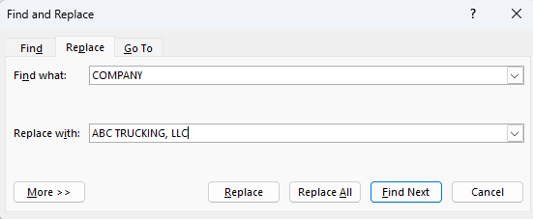

- Save the document in your computer’s local drive or cloud-based drive as a PDF file.

- Distribute a printed or digital version of the policy to each current driver and collect their signed Declaration and Certificate of Receipt to add to their driver qualification file if you do not already have one on file.

- Upload the policy to your BRAVO Compliance Dashboard.

